May 30th, 2022

CENG 431 Building Software Systems
Final Exam

Closed Book Exam. Answer the following questions in 75 minutes.

Questions:
- Draw the UML sequence diagram for performing a sale with respect to Figure 1 (15 pts). Fill the circles in Figure 1 with the order of implementation (5 pts) and explain why (5 pts). Write the Register and the Sale classes in Java (30 pts).
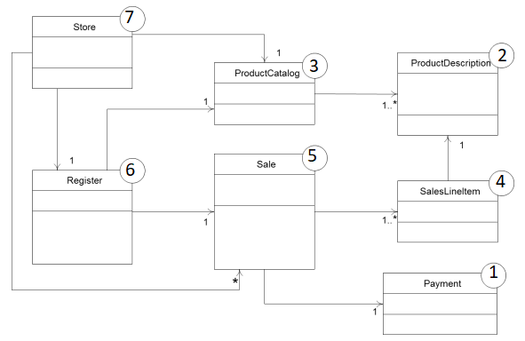
Figure 1. Class Diagram for Store Domain
Classes need to be implemented (and ideally, fully unit tested) from leastcoupled to most-coupled.
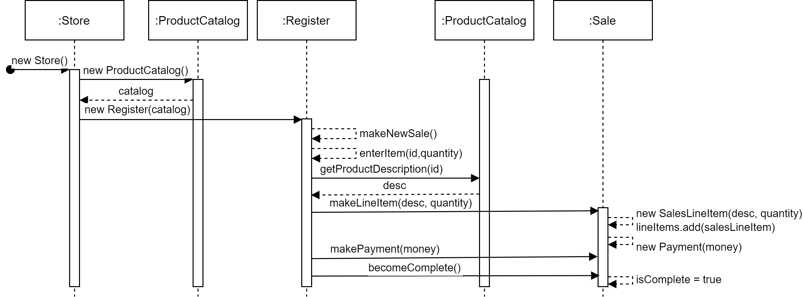
- Explain implementation of Strategy Design Pattern with one example in Java (20 points).

A class defines many behaviors, and these appear as multiple conditional statements in its operations. Instead of many conditionals, move related conditional branches into their own Strategy class.

-Strategy (Compositor) declares an interface common to all supported algorithms. Context uses this interface to call the algorithm defined by a ConcreteStrategy.
-ConcreteStrategy implements the algorithm using the Strategy interface.
-Context (Composition) is configured with a ConcreteStrategy object, maintains a reference to a Strategy object, and may define an interface that lets Strategy access its data.

public interface InterestStrategy {
public double interest(double principal, double rateOfInterest, int timePeriod);
}
public class SimpleInterest implements InterestStrategy {
@Override
public double interest(double principal, double rateOfInterest, int timePeriod) {
return principal * rateOfInterest * timePeriod;
}
}
public class CompoundInterest implements InterestStrategy {
@Override
public double interest(double principal, double rateOfInterest, int timePeriod) {
return principal * Math.pow((1 + rateOfInterest), timePeriod) - principal;
}
}
public class InterestCalculator {
private InterestStrategy strategy;
public InterestCalculator(InterestStrategy strategy) {
this.strategy = strategy;
}
public double calculateInterest(double principal, double rateOfInterest, int timePeriod) {
return strategy.interest(principal, rateOfInterest, timePeriod);
}
}
public class Demo {
public static void main(String[] args) {
InterestCalculator calculator = new InterestCalculator(new SimpleInterest());
System.out.println("Simple Interest = " + calculator.calculateInterest(200, 0.05, 7));
calculator = new InterestCalculator(new CompoundInterest());
System.out.println("Compound Interest = " + calculator.calculateInterest(200, 0.05, 7));
}
}

- List SOLID principles (10 points) and give an example for implementation of the “L” principle in Java (15 points).

Single Responsibility
Open/Closed
Liskov Substitution
Interface Segregation
Dependency Inversion
public class Square extends Rectangle {
@Override
public void setWidth(int width) {
super.setWidth(width);
super.setHeight(width);
}

@Override
public void setHeight(int height) {
super.setHeight(height);
super.setWidth(height);
}
}

Mathematically square is rectangle however, if we implement square as a rectangle, we violate Liskov Substitution Principle since their behaviors differ. Instead, we should implement rectangle and square as a shape:

public interface Shape {
long area();
}

public class Square implements Shape {
private int size;

public Square(int size) {
this.size = size;
}

@Override
public long area() {
return size * size;
}

public void setSize(int size) {
this.size = size;
}
}

public class Rectangle implements Shape {
private int width;
private int height;

public Rectangle(int width, int height) {
this.width = width;
this.height = height;
}

@Override
public long area() {
return width * height;
}

public void setWidth(int width) {
this.width = width;
}

public void setHeight(int height) {
this.height = height;
}
}

